Name: Yash Raj
Roll Number: 24K-0737
Task#1:
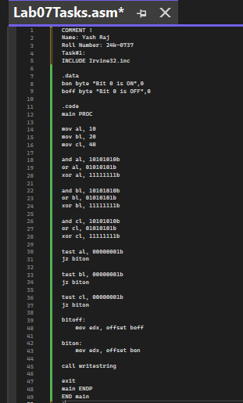
Output:
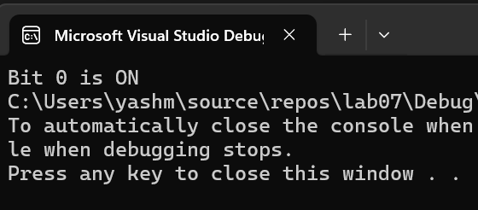
Task#2:
COMMENT !
Name: Yash Raj
Roll Number: 24k-0737
Task#2:
INCLUDE Irvine32.inc

.data
lu byte "Largest (unsigned) = ",0
ls byte "Largest (signed) = ",0
promptBad BYTE "Invalid input, please enter again",0

num1 dword ?
num2 dword ?
num3 dword ?

largestUnsigned SDWORD ?
largestSigned SDWORD ?

.code
main PROC

call readdec
mov num1, eax

call readdec
mov num2, eax

call readdec
mov num3, eax

mov eax, num1
mov ebx, num2
mov ecx, num3

cmp eax, ebx
jae not_bigger_unsigned_ebx
mov eax, ebx

not_bigger_unsigned_ebx:
cmp eax, ecx
jae not_bigger_unsigned_ecx
mov eax, ecx

not_bigger_unsigned_ecx:
mov largestUnsigned, eax

mov eax, num1
mov ebx, num2
mov ecx, num3

cmp eax, ebx
jge not_bigger_signed_ebx
mov eax, ebx

not_bigger_signed_ebx:
cmp eax, ecx
jge not_bigger_signed_ecx
mov eax, ecx

not_bigger_signed_ecx:
mov largestSigned, eax

call CrLf
mov edx, OFFSET lu
call WriteString
mov eax, largestUnsigned
call WriteInt

call CrLf
mov edx, OFFSET ls
call WriteString
mov eax, largestSigned
call WriteInt

call CrLf

call writestring

exit
main ENDP
END main
!

Output:
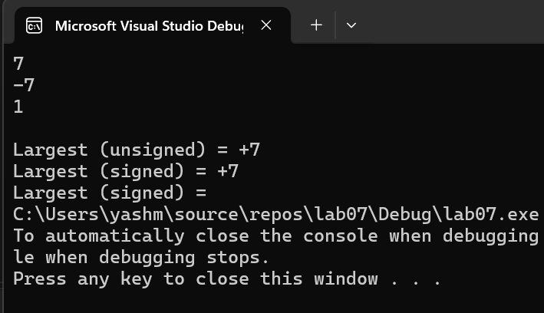

Task#3:
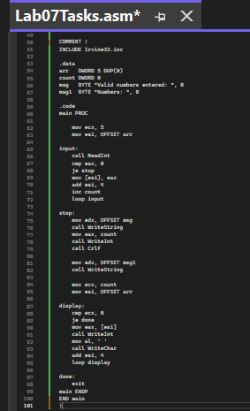
Output:
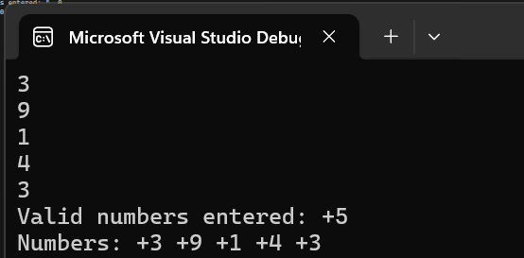

Task#4:
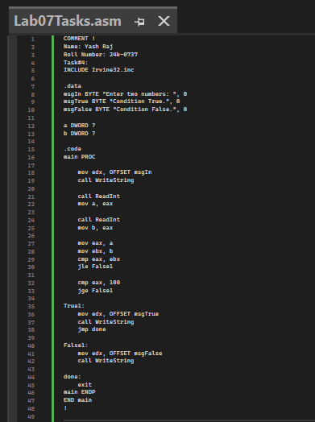
Output:
